
MEMORANDUM

To: | Charlie Refvem, Lecturer, Department of Mechanical Engineering, Cal Poly SLO
 | crefvem@calpoly.edu
From: | Quinn Patterson
 | qpatters@calpoly.edu
 | Jake Rowen
 | jhrowen@calpoly.edu
Team:  Date: | 23  2/11/26
RE: | Lab 0x03

For this lab we utilized the demo task design, implementing our code where necessary to run the PI control. Our PI control worked properly, giving a transient response that results in a stable value.

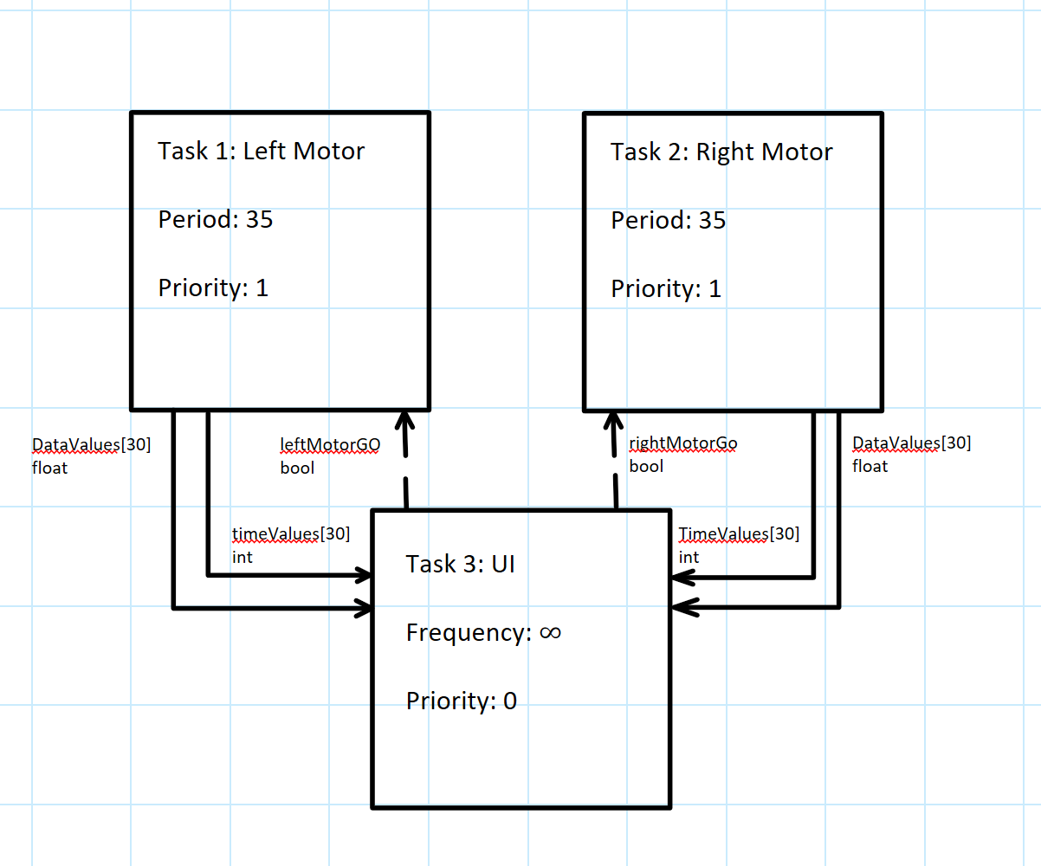
Figure 1: Task Diagram

The user interface task is responsible for setting flags to initiate the step response tests and data collection. The share value “leftMotorGo” is when the user types an ‘L’ into the command prompt, and conversely the rightMotorGO is set by typing an ‘R’. This triggers a step response test that runs either the left or right motor tasks at a period of 35 ms (28.6 Hz). The motor tasks put both time and velocity values in the TimeValues and DataValues queues until they become full (30 values). When this is complete the user interface task retrieves the data from the queues and displays them for the user, and finally resets and waits for another user input.
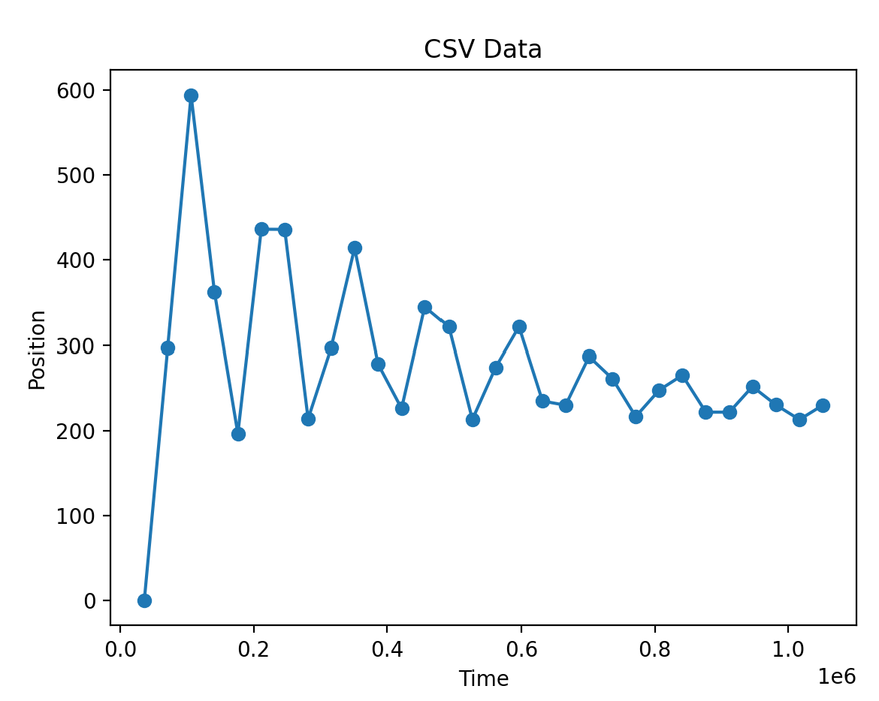
Figure 2. Step Response Data

Our step response was plotted with mm on the y axis and microseconds on the x axis. The response ran for a little over one second and began to asymptotically approach around 235mm/s. This shows a stable, albeit very roughly tuned response that will be improved in the next lab.

Attachments:
- State Transition Diagrams:
